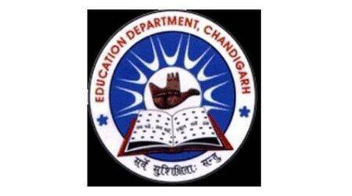
School Code : 24208 | Affiliation No. 2620025
GOVERNMENT MODEL SENIOR SECONDARY SCHOOL
SECTOR 38 WEST DMC CHANDIGARH. PHONE : 0172-2617001
Website: www.gmsss38wdmc.in. E-Mail ID: gsss38west@yahoo.in

MEMO NO : DATE:5/5/2021
FIRE SAFETY CERTIFICATE
It is hereby certified that building is constructed with safety measures and thirteen (13) fire extinguishers have been installed at appropriate places in the school premises.

PRINCIPAL
GMSSS 38 WEST DMC

